
PRESS RELEASE……………..……………………………………..……………………………………

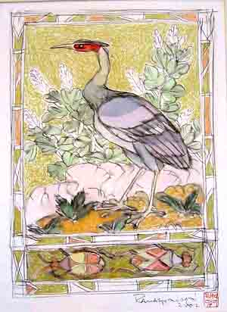

Presents

MODERN AND CONTEMPORARY INDIAN ART

16th April - 11th May 2007

Grosvenor Vadehra is a recent collaboration between the Grosvenor Gallery, London, and the Vadehra Art Gallery, New Delhi for the promotion of International art within India and Indian art within the UK.

“Indian Art is at a critical Juncture…Soaring saleroom prices, frantic buying (and selling)…have made it a veritable hothouse. As debates rage on, practicing artists in India are engaged in creating some of the most exciting and challenging work worldwide. New art from India is finally beginning to get the attention it deserves” Amrita Jhaveri.

Modern and Contemporary Indian Art will look at a selection of Indian artists uniting the older Indian progressives with a younger generation of Indian Artists.

Highlights include a collection of line drawings by the internationally acclaimed artist F. N. Souza as well as large-scale photographs by Rameshwar Broota.

Grosvenor Vadehra: London / New Delhi

Artists exhibiting:

Rameshwar BROOTA
Jogen CHOWDHURY
M.F. Husain
Ram KUMAR
Akbar PADAMSEE
Jagannath PANDA
Ashim PURKAYASTHA
A. RAMACHANDRAN
S.H.RAZA
Arpita SINGH
Francis Newton SOUZA

_________________________________________________________________________________

Contact : Emily Austin, Grosvenor Vadehra, 21 Ryder Street , London, SW1Y 6PX,
T: +44 (0)20 7484 7979 F: +44 (0)20 7484 7980 E: emily@grosvenorgallery.com W: www.grosvenorvadehra.com

