MARK SHIELDS
Galerie Brusberg, Berlin 2007

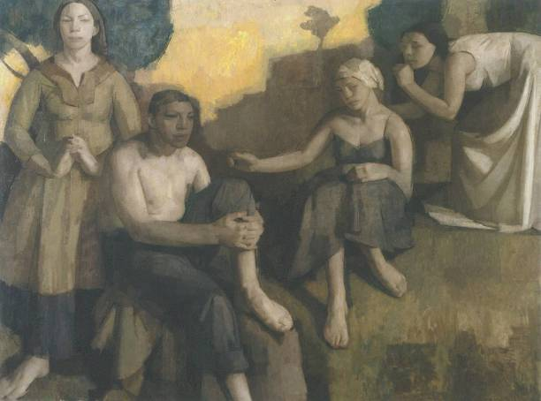

Intimations, 2005
182 x 244 cm (6 x 8ft)
BK 15124

€45,000

BK15167 | 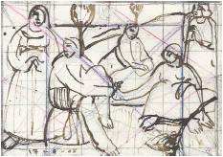 | Intimations I  17-9-05  14.5 x 20.8 cm | N.F.S
BK15196 | 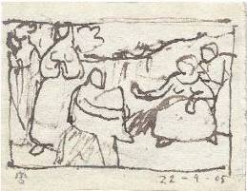 | Intimations II  22-9-05  11.2 x 14.5 cm | €680
BK15155 | 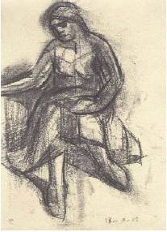 | Intimations III  18-10-05  28.8 x 20.7 cm | €1,250

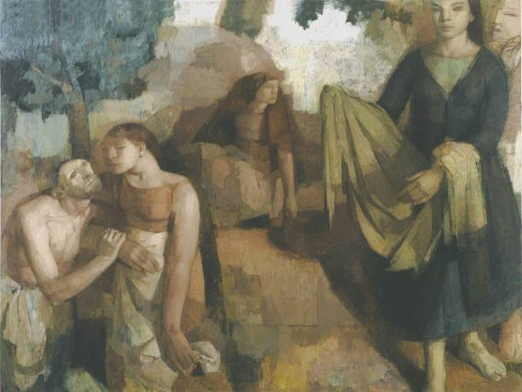

Miracle, 2005
182 x 244 cm (6 x 8 ft)
BK 15125

€45,000

BK15171 | 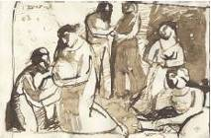 | Miracle I  25-5-05  14.7 x 22.3 cm | €900
BK15201 | 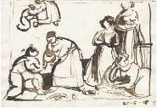 | Miracle II  25-5-05  14.9 x 22.3 cm | €900
BK15174 | 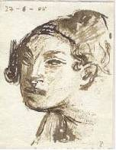 | Miracle III  27-6-05  14.4 x 11.1 cm | €680
BK15175 | 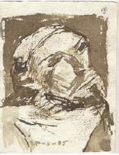 | Miracle IV  27-06-05  14.4 x 11.2 cm | €680
BK15199 | 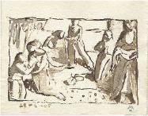 | Miracle V  28-6-05  11.2 x 14.5 cm | €680
BK15200 | 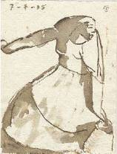 | Miracle VI  7-7-05  14.5 x 11.2 cm | SOLD
BK15172 | 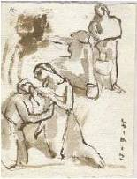 | Miracle VII  13-7-05  14.9 x 11.2 cm | SOLD
BK15173 | 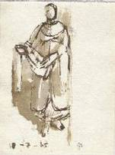 | Miracle VIII  18-7-05  14.6 x 11.2 cm | €680
BK15197 | 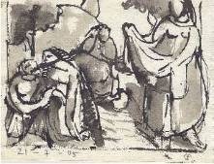 | Miracle IX  21-7-05  11.2 x 14.7 cm | €680

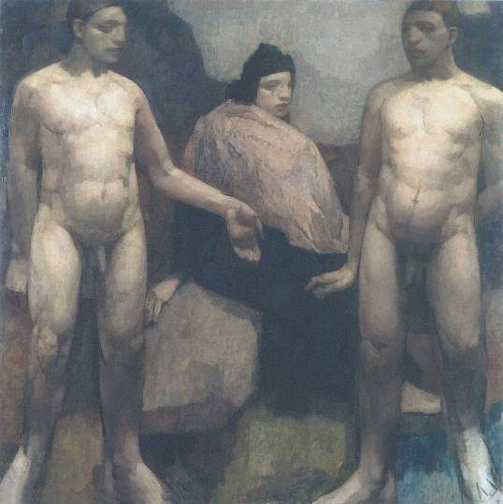

The Headland, 2005/6
182 x 182 cm (6ft x 6ft)
BK 15126

€40,000

BK15191 | 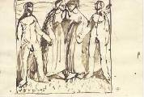 | The Headland I  3-1-05  14.3 x 20.9 cm | N.F.S
BK15194 | 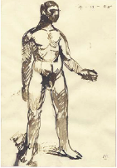 | The Headland II  4-11-05  20.9 x 14.5 cm | N.F.S
BK15193 | 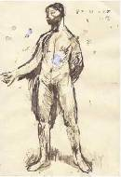 | The Headland III  8-11-05  20.9 x 14.2 cm | N.F.S
BK15184 | 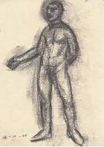 | The Headland IV  14-11-05  28.8 x 20.5 cm | €1,250
BK15198 | 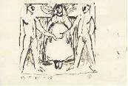 | The Headland V  14-11-05  14.4 x 21 cm | N.F.S
BK15185 | 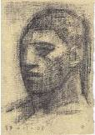 | The Headland VI  17-11-05  21.8 x 15 cm | €980
BK15163 | 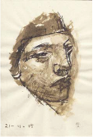 | The Headland VII  21-11-05  20.9 x 14 cm | €980
BK15164 | 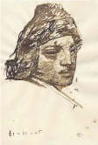 | The Headland VIII  11-11-05  20.9 x 14 cm | €980
BK15158 | 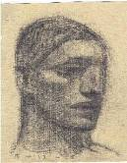 | The Headland IX  5-12-05  21.8 x 17.5 cm | €980
BK15192 | 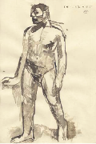 | The Headland X  15-12-05  20.9 x 14.1 cm | N.F.S

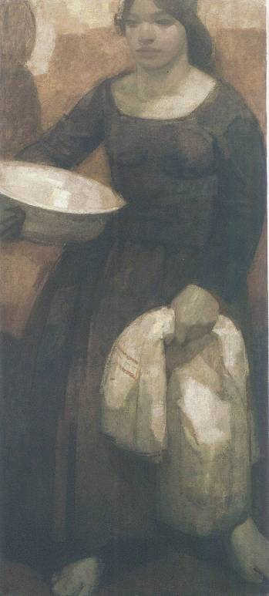

Woman Carrying Basin, 2006
152 x 68.5 cm (5ft x 2 ¼ ft)
BK 15127

€26,000

BK15154 | 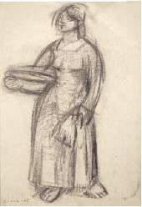 | Woman Carrying a Basin I  21-12-05  42 x 28.8 cm | €1,500
BK15165 | 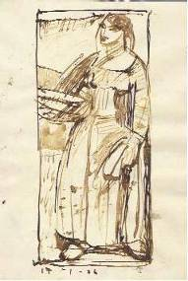 | Woman Carrying a Basin II  17-1-06  20.9 x 14 cm | €900
BK15166 | 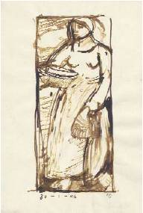 | Woman Carrying a Basin III  30-1-06  20.9 x 14 cm | €900

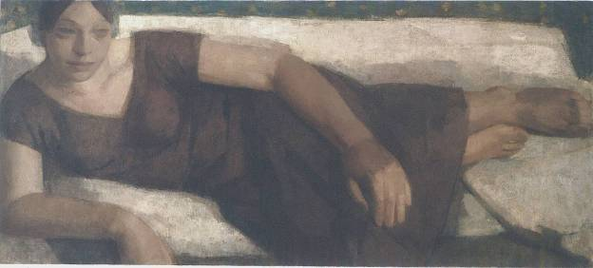

Reclining Woman, 2006
68.5 x 152.5 cm (2 ¼ x 5 ft)
BK 15128

€26,000

BK15160 | 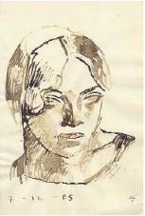 | Reclining Woman I  7-12-05  21 x 14 cm | €980
BK15162 | 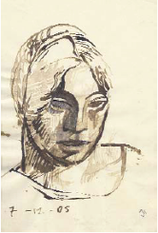 | Reclining Woman II  7-12-05  20.9 x 14 cm | €980
BK15161 | 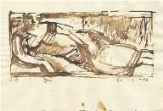 | Reclining Woman III  20-1-06  14.2 x 20.8 cm | €900
BK15186 | 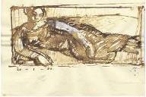 | Reclining Woman IV  20-1-06  14.2 x 20.8 cm | €900

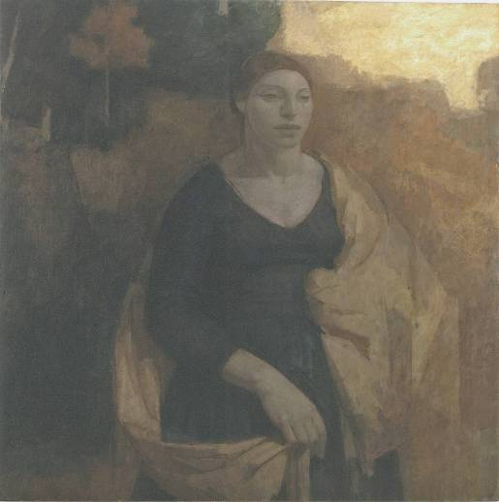

Protectress, 2006
122 x 122 cm (4 x 4 ft)
BK15129

€26,000

BK15178 | 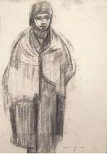 | Protectress I  29-12-05  42 x 28.7 cm | N.F.S
BK15169 | 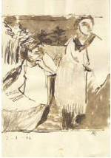 | Protectress II  3-1-06  20.9 x 14.3 cm | €900
BK15168 | 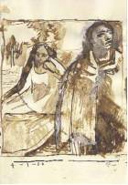 | Protectress III  4-1-06  20.9 x 14.3 cm | €900
BK15170 | 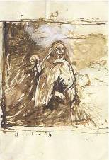 | Protectress IV  16-1-06  20.8 x 14.2 cm | N.F.S

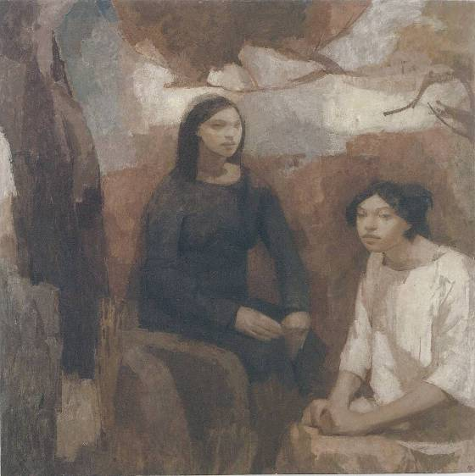

Guardians, 2006
122 x 122 cm (4ft x 4ft)
BK15130

€26,000

BK15153 | 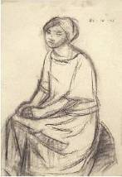 | Guardians I  29-12-05  42 x 28.8 cm | €1,500
BK15179 | 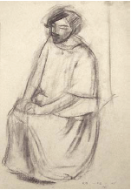 | Guardians II  42 x 28.7 cm | N.F.S
BK15202 | 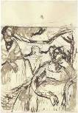 | Guardians III  3-1-06  21 x 14.4 cm | N.F.S
BK15203 | 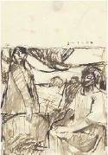 | Guardians IV  3-1-06  20.9 x 14.9 cm | N.F.S
BK1595 | 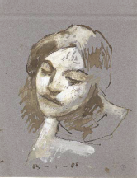 | Guardians V  13-1-05  19.8 x 15.3 cm | SOLD
BK15157 | 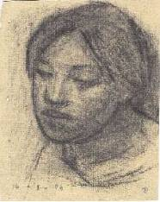 | Guardians VI  16-1-06  21.8 x 17.6 cm | €980

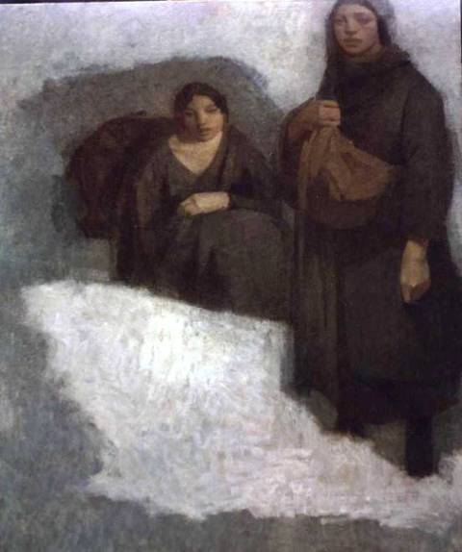

Snow, 2006
122 x 102 cm (4 x 3 1/3 ft)
BK 15131

€26,000.00

BK15183 | 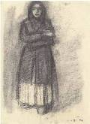 | Snow I  11-8-04  28.9 x 20.8 cm | €1,250
BK15159 | 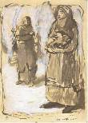 | Snow II  15-6-05  21 x 15 cm | €900
BK15181 | 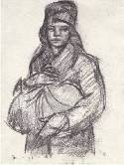 | Snow III  7-11-05  28 x 21 cm | €1,250
BK5187 | 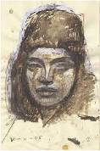 | Snow IV  30-11-05  20.9 x 13.9 cm | €980
BK15177 | 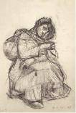 | Snow V  21-12-05  42 x 28.7 cm | €1,500
BK15180 | 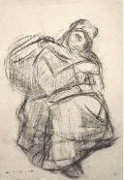 | Snow VI  21-12-05  42 x 28.7 cm | €1,500
BK15189 | 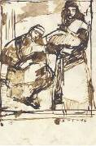 | Snow VII  5-1-06  20.9 x 14.1 cm | €900
BK15190 | 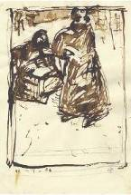 | Snow VIII  11-1-06  20.9 x 14.2 cm | N.F.S
BK15188 | 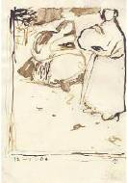 | Snow IX  12-1-06  20.9 x 14.4 cm | N.F.S

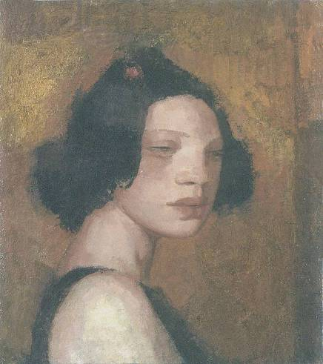

Ideal Head I, 2006
45.5 x 40.5 cm (18 x 16 in.)
BK 15132

€8,000

BK15176 | 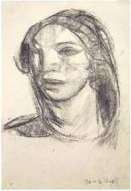 | Ideal Head I  20-4-06  42 x 28.7 cm | €1,500

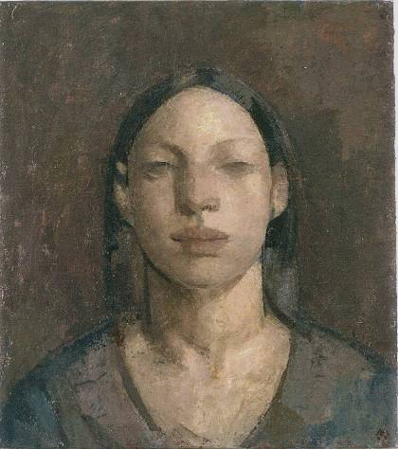

Ideal Head II, 2006
45.5 x 40.5 cm (18 x 16 in.)
BK15133

€8,000

BK15152 | 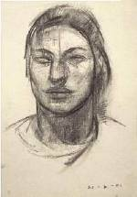 | Ideal Head II  21-4-06  42 x 28.8 cm | €1,500

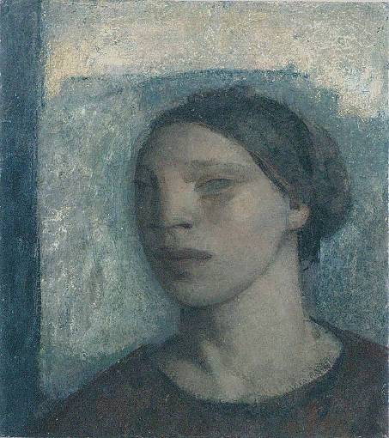

Ideal Head III, 2006
45.5 x 40.5 cm (18 x 16 in.)
BK15134

€8,000

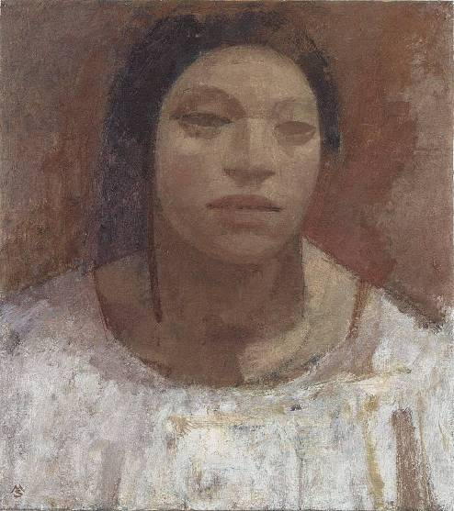

Ideal Head IV, 2006
45.5 x 40.5 cm (18 x 16 in.)
BK15135

€8,000

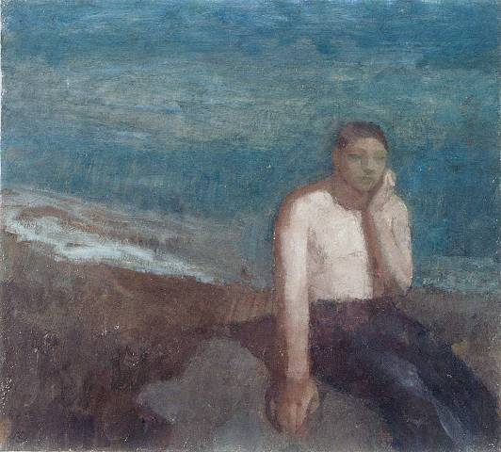

Young Man by the Shore, 2006
45.5 x 40.5 (18 x 16 in.)
BK15136

€9,000

BK15182 | 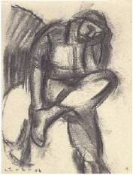 | Young Man by the shore  22-6-06  28.6 x 22.4 cm | €1,250

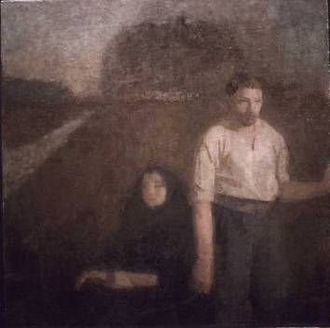

Pilgrims, 2006
50.5 x 50.5 cm (20 x 20 in.)
BK15137

€9,000

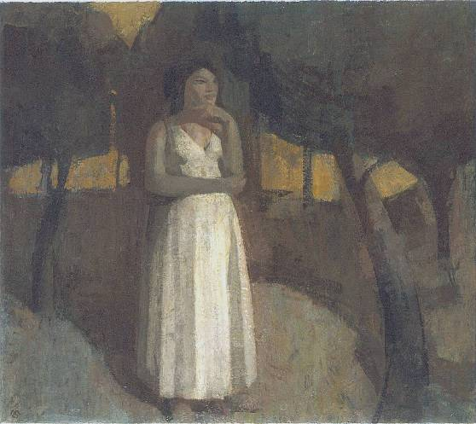

The Call, 2006
40.5 x 45.5 cm (16 x 18 in.)
BK15138

€9,000

BK15156 | 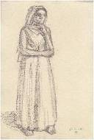 | The Call  8-7-03  29.7 x 20 cm | €1,250

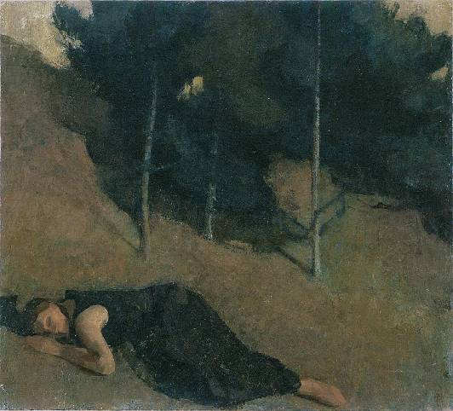

Sleeper, 2006
45.5 x 50.5 cm (18 x 20 in.)
BK15139

€9,000

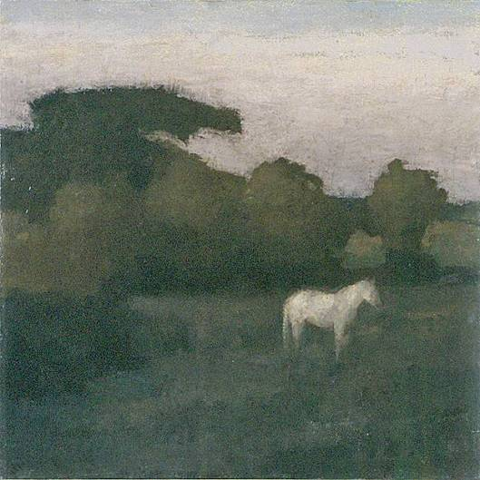

White Horse, 2006
50.5 x 50.5 (20 x 20 in.)
BK15140

€9,000

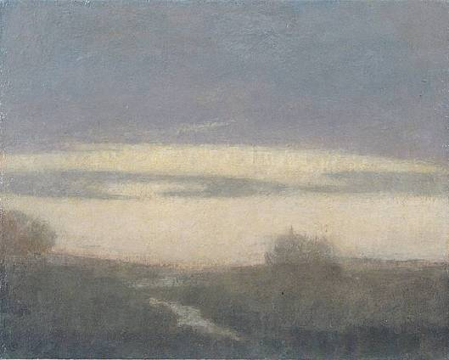

The Land to the North, 2006
40.5 x 50.5 cm (16 x 18 in.)
BK 15141

€9,000

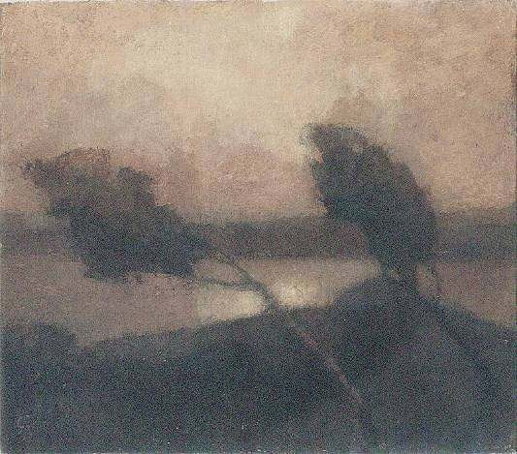

Ancient Landscape, 2006
40.5 x 45.5 cm (16 x 18 in.)
BK 15142

€9,000

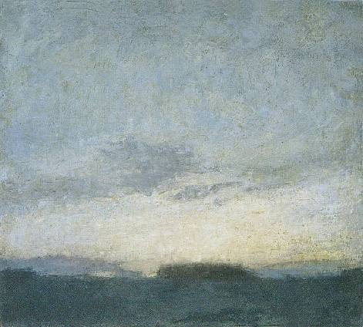

The Cops (Morning), 2006
40.5 x 45.5 cm (16 x 18 in.)
BK 15143

€9,000

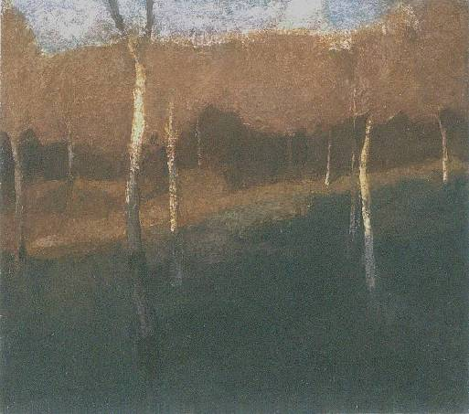

Plantation, 2006
40.5 x 45.5 cm (16 x 18 in.)
BK 15144

€9,000

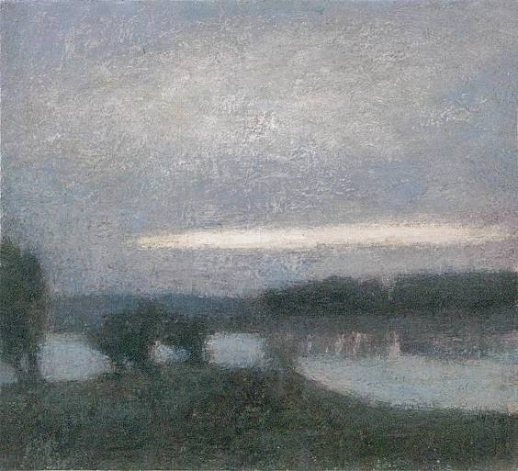

Silent Lake, 2006
40.5 x 45.5 cm (16 x 18 in.)
BK15145

€9,000

