SHIBU NATESAN
External Affairs

List of works

1. | External Affairs I  2008  Oil on Linen  180 x 213.5cm (84 x 70 ½ in)  (7 x 5.8 ft) |  | £50,000
2. | External Affairs II  2008  Oil on Linen  178 cm x 176.5cm (70 x 69 ½ in)  (6 x 6 ft) | 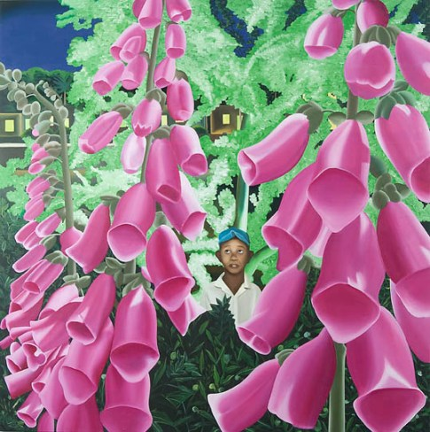 | £40,000
3. | No Speech II  2008  Oil on canvas  229 cm x 274cm (90 x 108in)  (8 x 10 ft) | 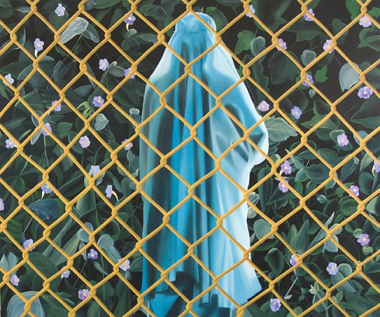 | £60,000
4. | External Affairs III  2008  Oil on canvas  122cm x 137 cm (48 x 54 in)  (4 x 4 ½ ft) | 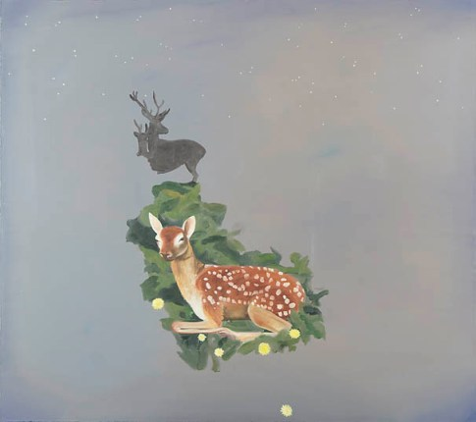 | £25,000
5. | Still Life  2008  Oil on canvas  51 x 61 cm (20 x 24 in)  (1 ½ x 2 ft) | 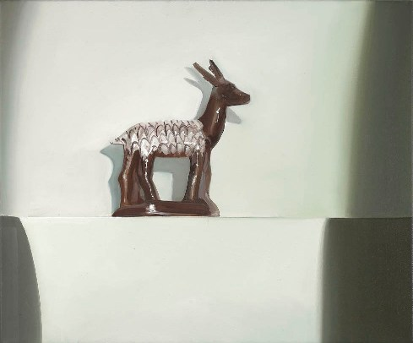 | £7,000
6. | External Affairs IV  2008  Oil on canvas  25.5cm x 30cm (10 x 11 ¾ in)  (1 x 1 ft) | 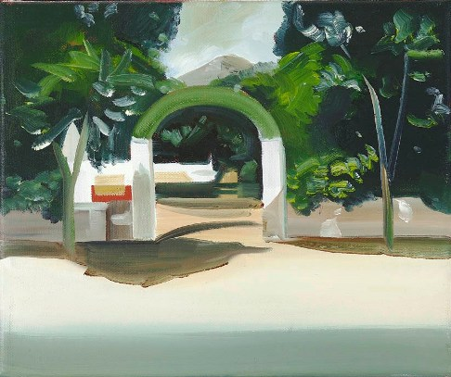 | £4,000
7. | Immigrant I  2008  Oil on canvas  30cm x 25.5 cm (11 ¾ x 10 in)  (1 x 1 ft) | 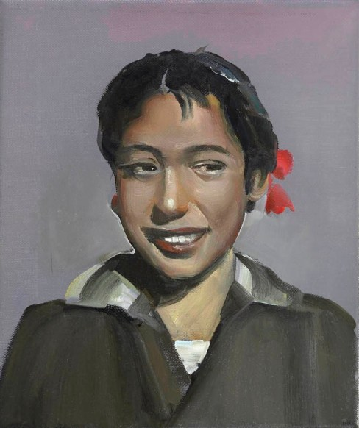 | £4,000
8. | Ashram  2007  Oil on canvas  46 x 40.5 cm (8 ¼ x 16 in)  (½ x 1 ft) | 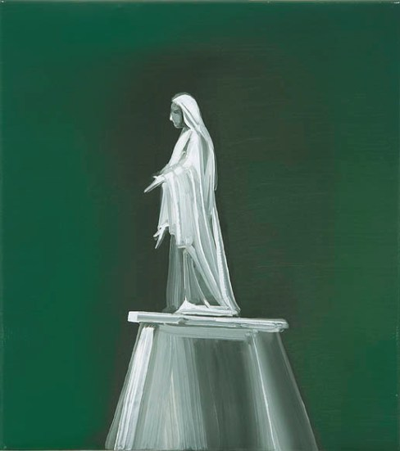 | £6,000
9. | Immigrant II  2007  Oil on canvas  31 x 20.5cm (12 ¼ x 8 in)  (1 x ½ ft) | 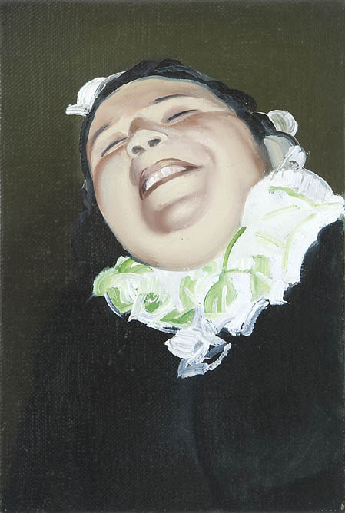 | £4,000
10. | House of Suspense  2008  Oil on canvas  51 x 61 cm (20 x 24 in)  (1 ½ x 2 ft) | 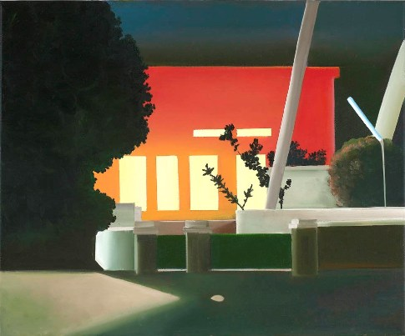 | £7,000  SOLD: 2570
11. | No Speech  2008  Oil on canvas  226.5cm x 272 cm (89 ½ x 107 in)  (7 ¼ x 9 ft) | 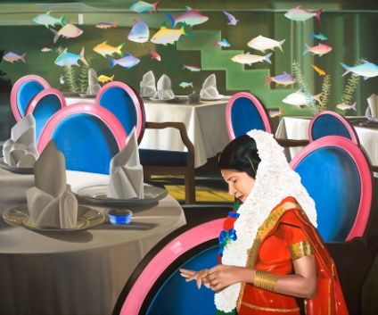 | N.F.S

